**Calling a Function: -**

* Once the basic structure of a function is finalized, you can execute it by calling it from another function or directly from the Python prompt.

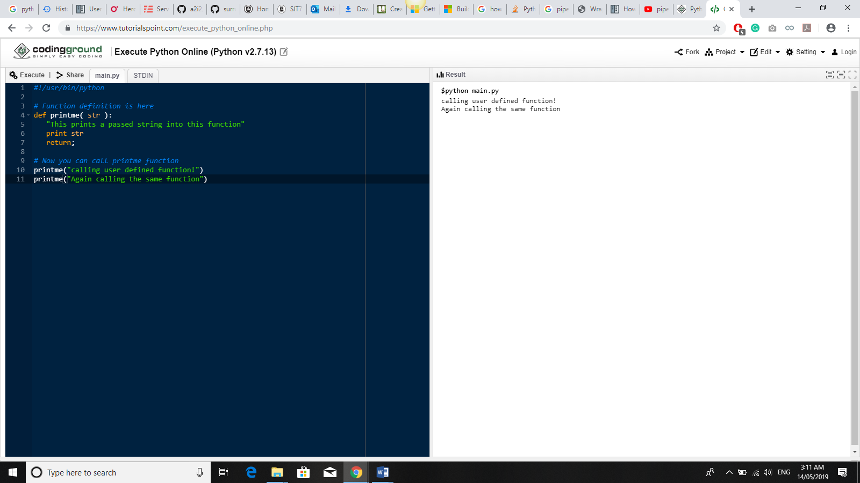

* You can call a function by using the following types of formal arguments: −
* Function Arguments
* Required arguments
* Keyword arguments
* Default arguments
* Variable-length arguments

🡪 Operate function in surround framework is really important.

* Calling function in surround: -
* surround_data.freeze()
* self.surround.init_stages()